Blueberry Pancakes

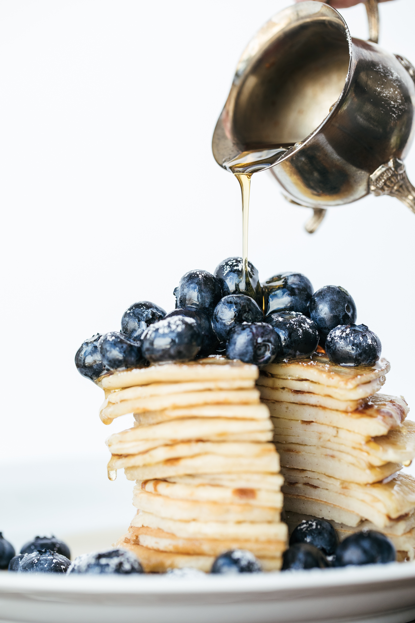

Ingredients:

* 200g self-raising flour
* 1 tsp baking powder
* 1 egg
* 300ml milk
* knob butter
* 150g pack of blueberry
* sunflower oil or a little butter for cooking
* golden or maple syrup

Instructions:

1. Mix together flour, baking powder and a pinch of salt in a [large bowl](https://www.bbcgoodfood.com/content/top-five-mixing-bowls).
2. Beat the egg with milk, make a well in the center of the dry ingredients and [whisk](https://www.bbcgoodfood.com/content/top-five-whisks)ing the milk to make a thick smooth batter.
3. Beat in a knob of butter, and gently stir in blueberries.
4. Heat the sunflower oil or butter in a large [non-stick frying pan](https://www.bbcgoodfood.com/content/top-five-non-stick-frying-pans).
5. Drop a large tablespoonful of the batter per pancake into the pan to make pancakes about 7.5cm across. Make three or four pancakes at a time.
6. Cook for about 3 minutes over a medium heat until small bubbles appear on the surface of each pancake, then turn and cook another 2-3 minutes until golden.
7. Cover with kitchen paper to keep warm while you use up the rest of the batter.
8. Serve with golden or maple syrup and the rest of the blueberries

Hot Chocolate Smoothie Bowl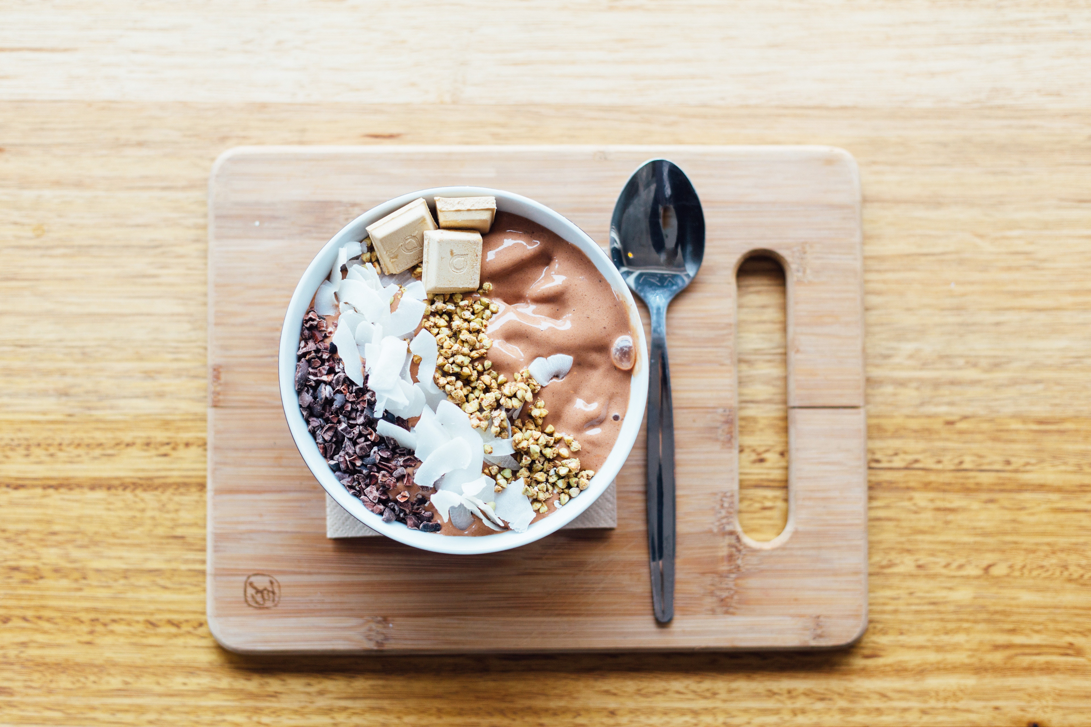

Ingredients:

* 1 cup (240 ml) unsweetened almond milk
* 1 Tbsp (16 g) nut butter OR dairy-free chocolate chips
* 1 Tbsp (15 ml) maple syrup*
* 1/2 cup (40 g) rolled oats
* 2 Tbsp (10 g) unsweetened cocoa powder
* 1/2 tsp vanilla extract

Instructions:

1.The night before, add all ingredients (except chocolate chips, if using) to the bowl of your blender and give it a stir to ensure that everything is well combined. Cover and place in fridge for at least 3 hours, preferably overnight. This step isn't absolutely necessary, but allowing the oats to soak for a few hours will make them easier to blend and give you a smoother, creamier smoothie.

2.When ready to eat, blend on high until oats are fully broken down and a smooth and creamy consistency is reached.

3.Transfer the smoothie to a small saucepan set over medium heat (adding chocolate chips, if using) and bring to a simmer or boil, depending on how hot you want it. If the smoothie is too thick, add an extra splash of almond milk until desired consistency is reached.

4.When your smoothie reaches your preferred temperature, transfer it to a bowl, garnish with toppings of choice, and enjoy!

Chicken Laksa

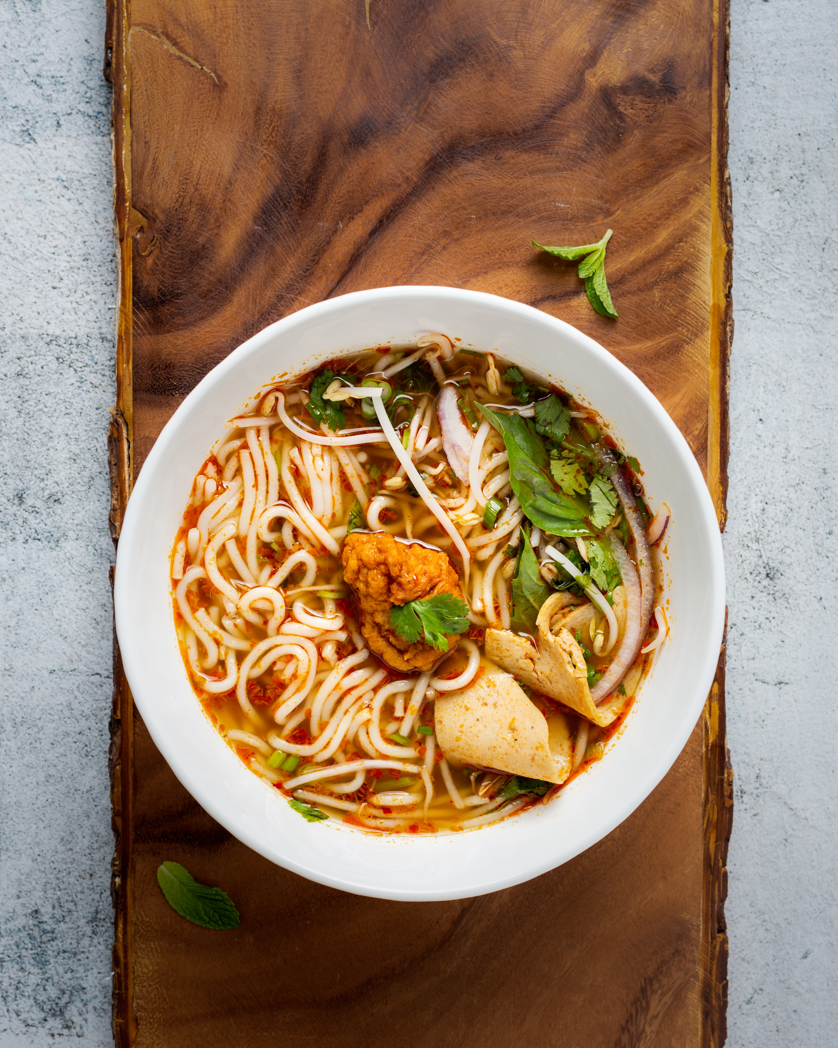

Ingredients:

* + - 200g thin Thai-style rice noodles
    - 1 red capsicum, thinly sliced
      * 400g chicken breast fillets, trimmed, cut into strips
      * 1/3 cup laksa paste
      * 4 cups reduced-salt chicken stock
      * 20 snow peas, trimmed
      * 425g can baby corn, drained, halved
      * 375ml can coconut-flavored light evaporated milk
      * 2 green onions, sliced diagonally
      * 2 tablespoons coriander leaves

Instructions:

* Place noodles into a bowl and cover with boiling water. Stand for 15 minutes. Drain.
* Meanwhile, spray a frying pan with oil. Cook capsicum and chicken over medium-low heat for 4–5 minutes, until golden.
* Transfer to a large saucepan, add paste and stock and bring to the boil. Add snow peas and corn and simmer for 2–3 minutes. Stir through evaporated milk.
* Divide noodles between bowls. Top with soup and garnish with onion and coriander.